SAP MDK 2310 METADATA DEPLOYMENT
Step 1: Open software center from me.sap.com and download 2310 metadata
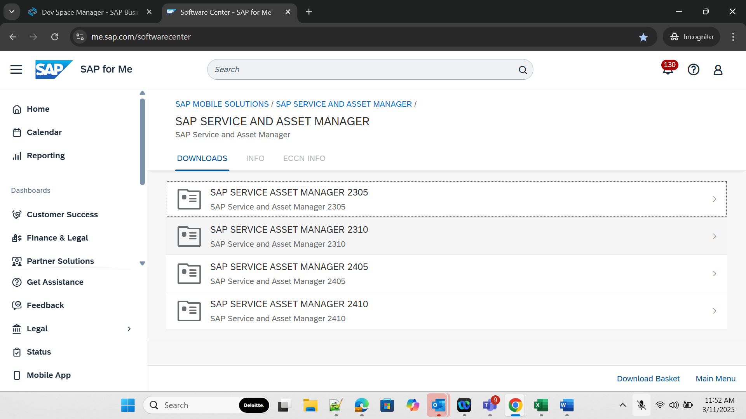

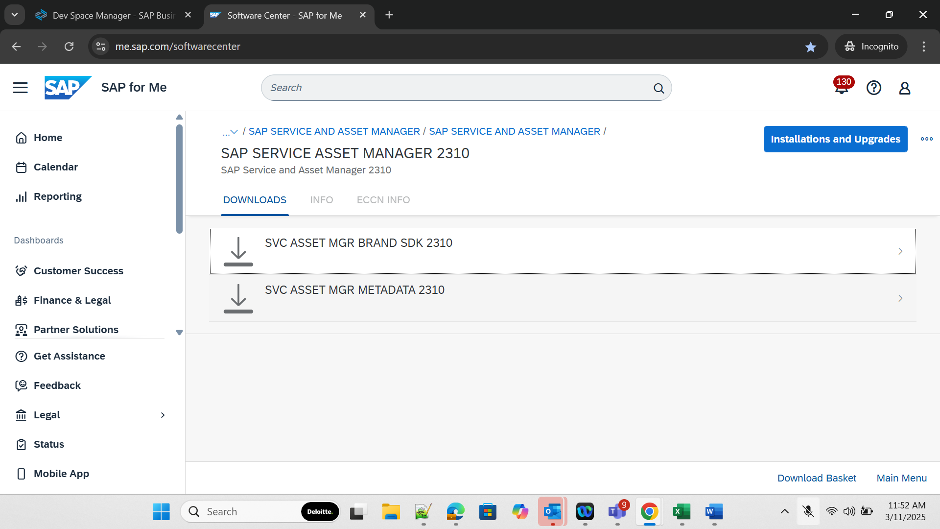

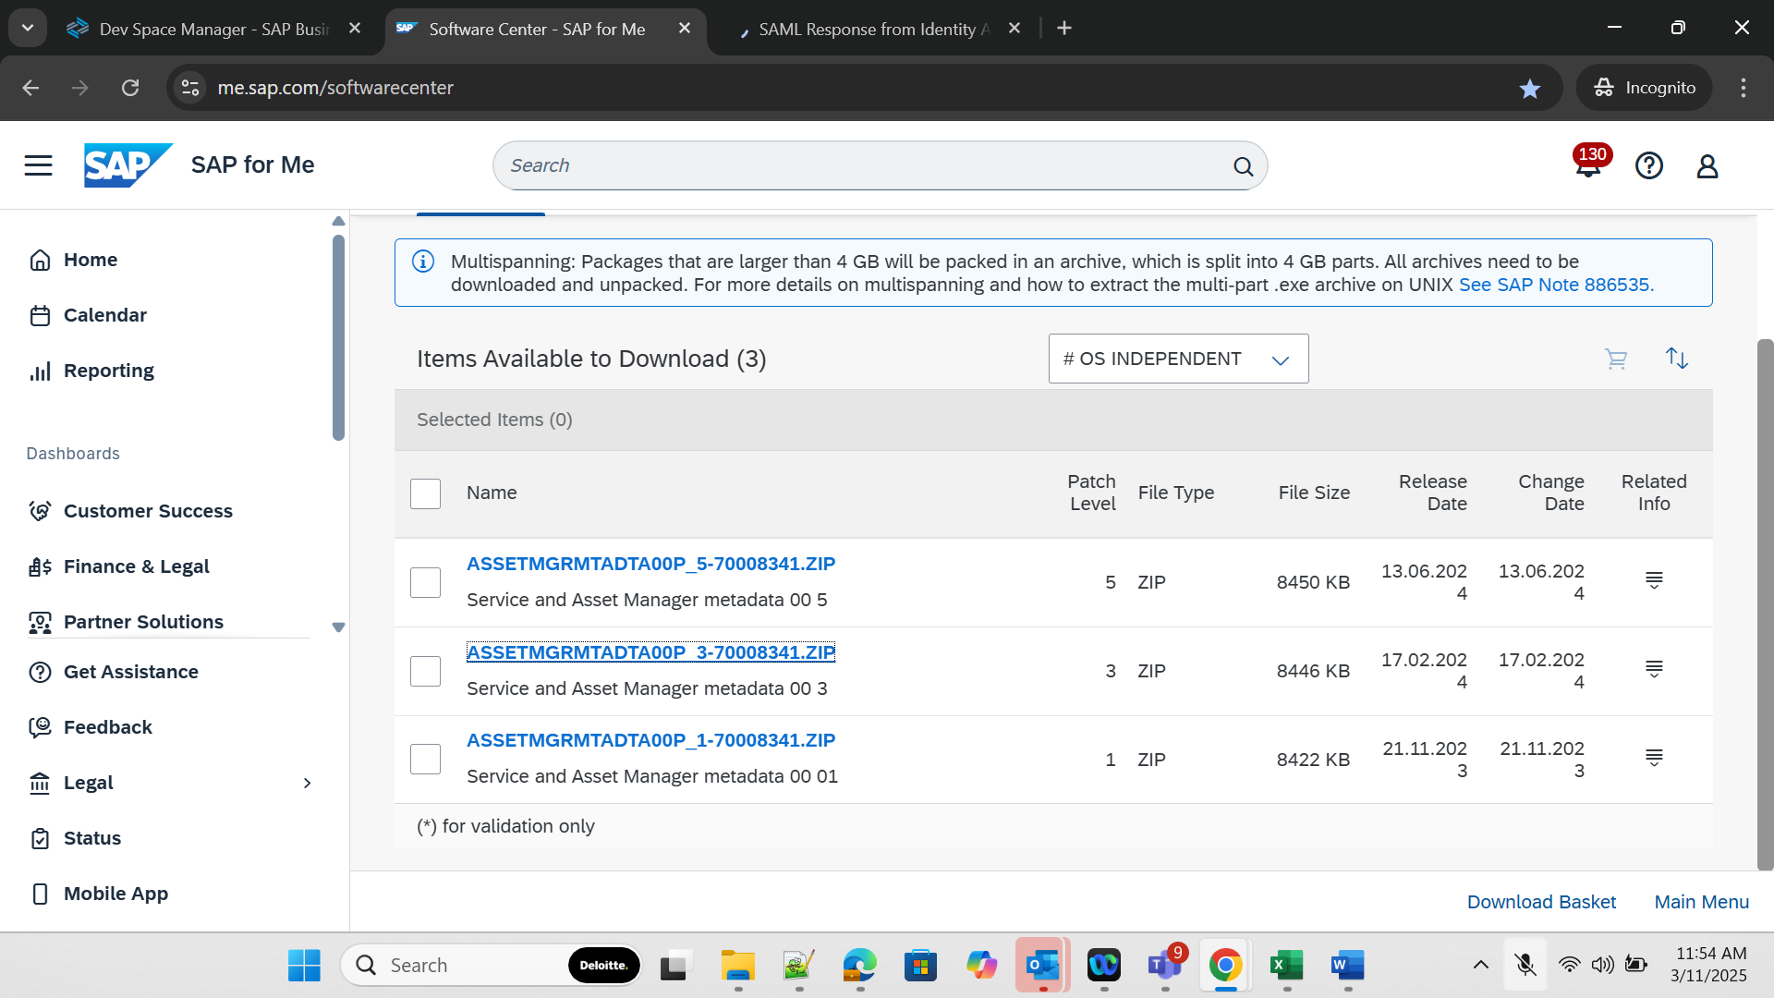

Step 2: Login to SAP Business Application Studio and import the downloaded metadata
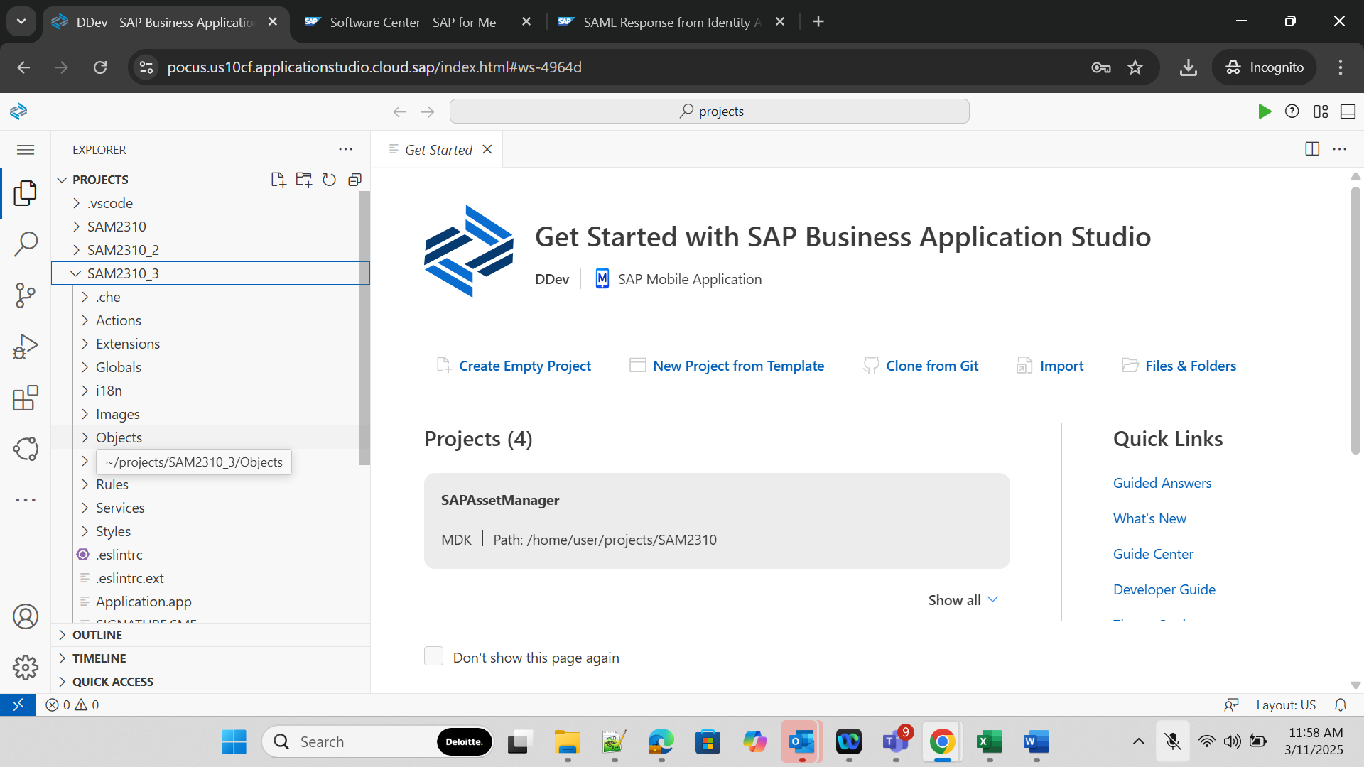

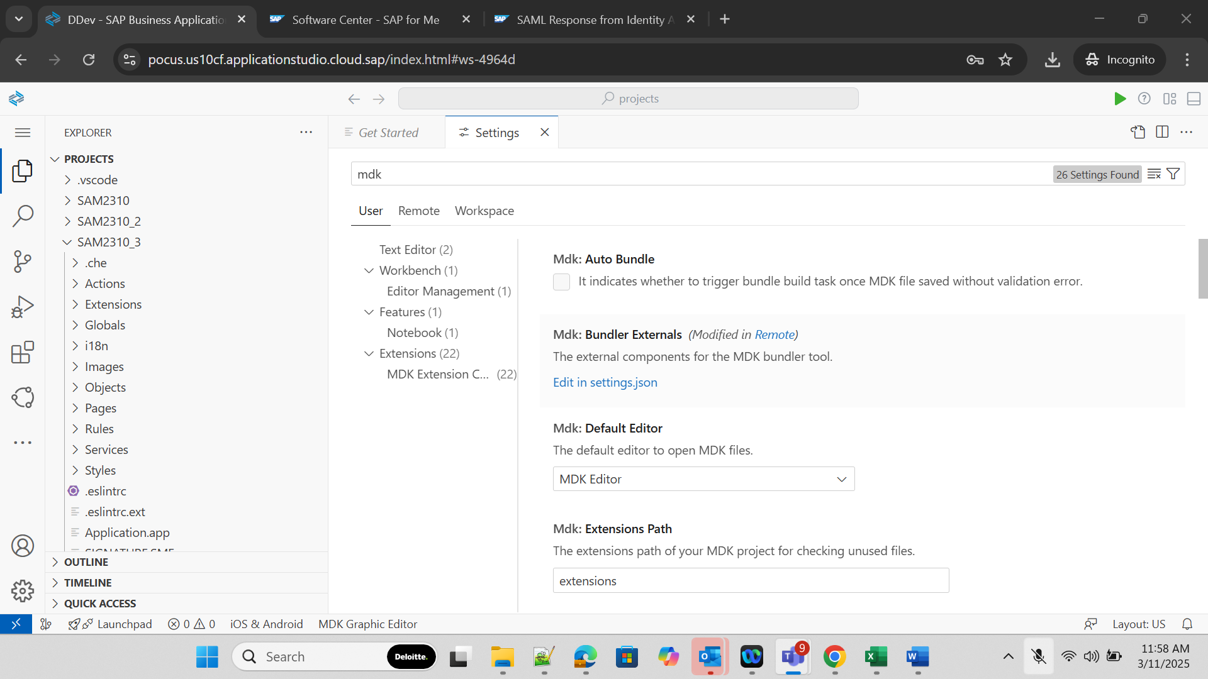
Step 3: In the settings.json, update the external bundlers as follows
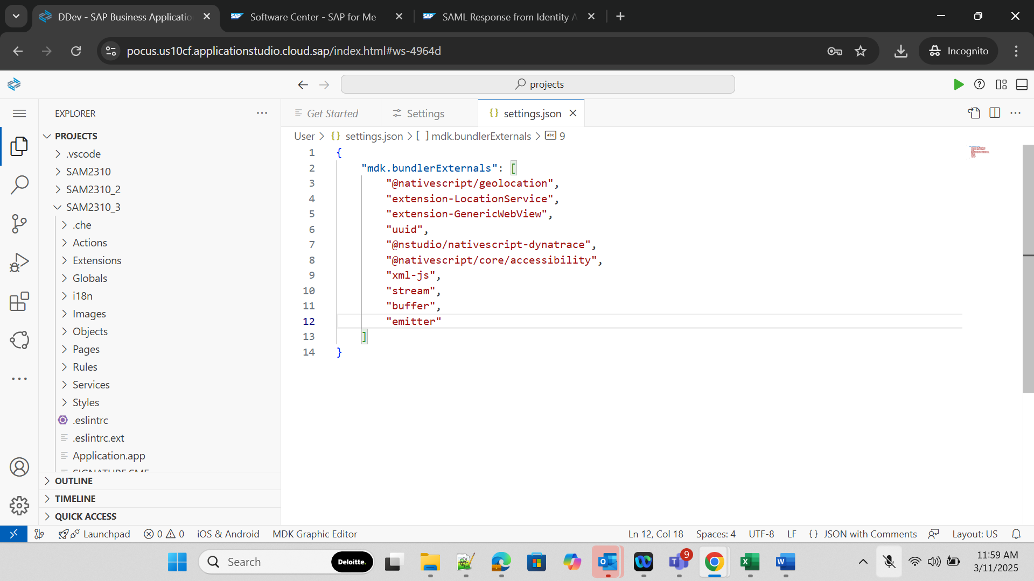

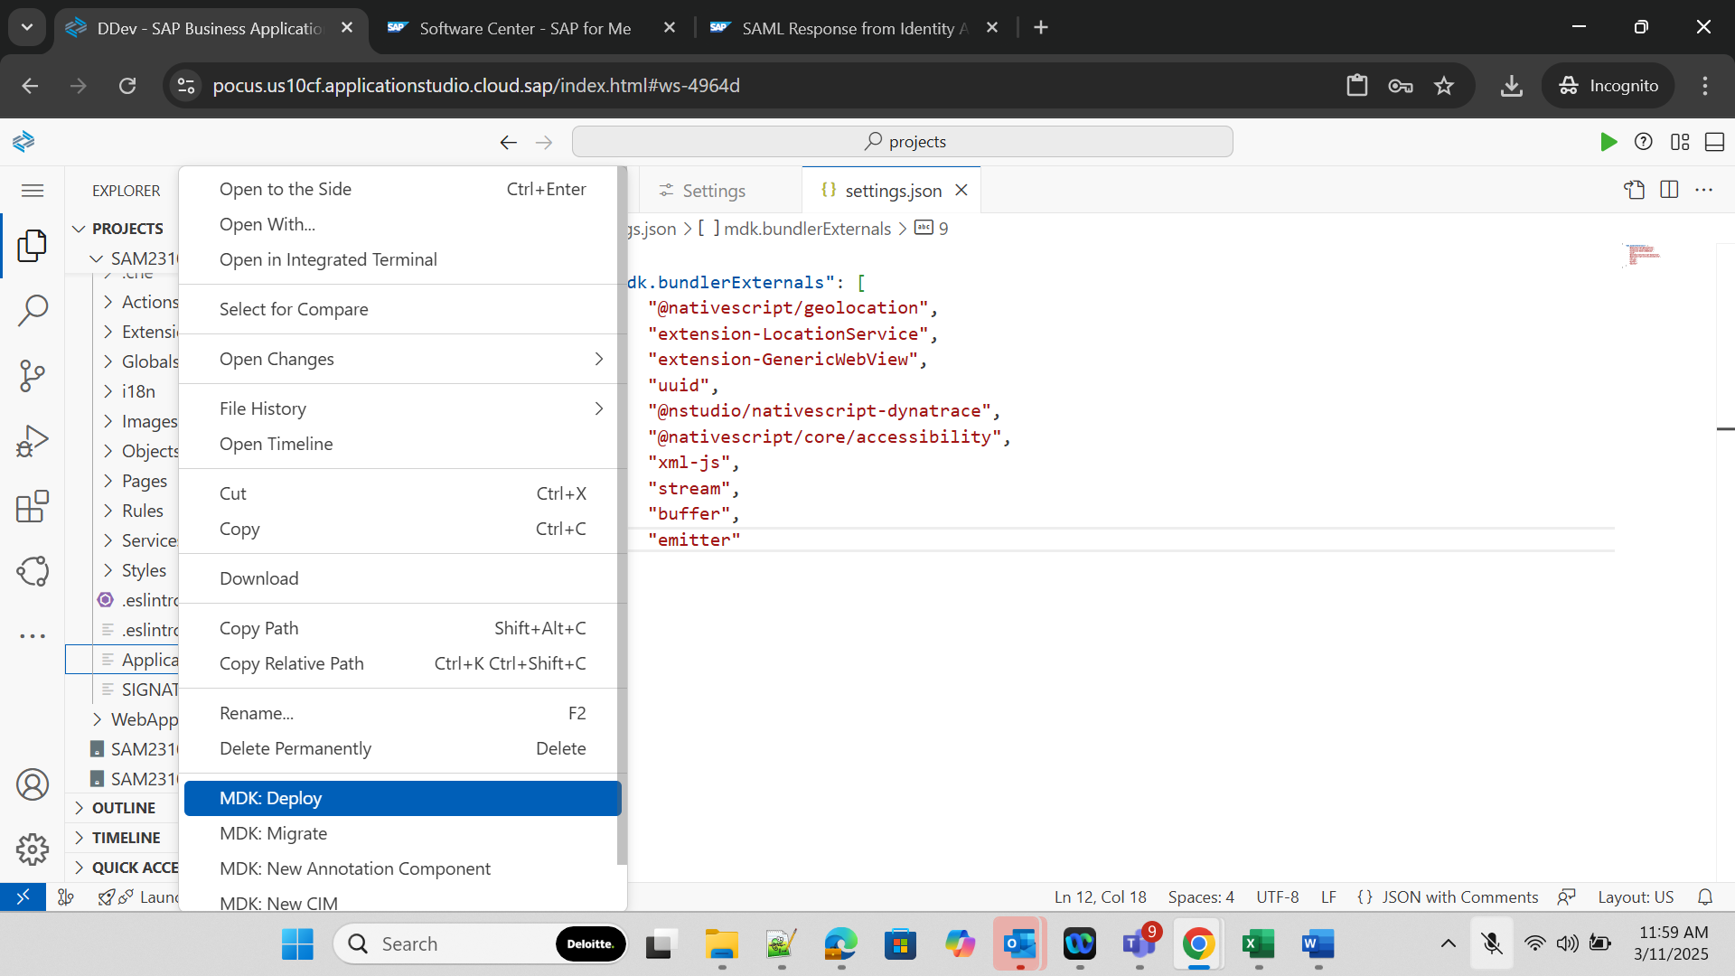
Step 4: Right click on Application.app and Deploy MDK in the mobile service.
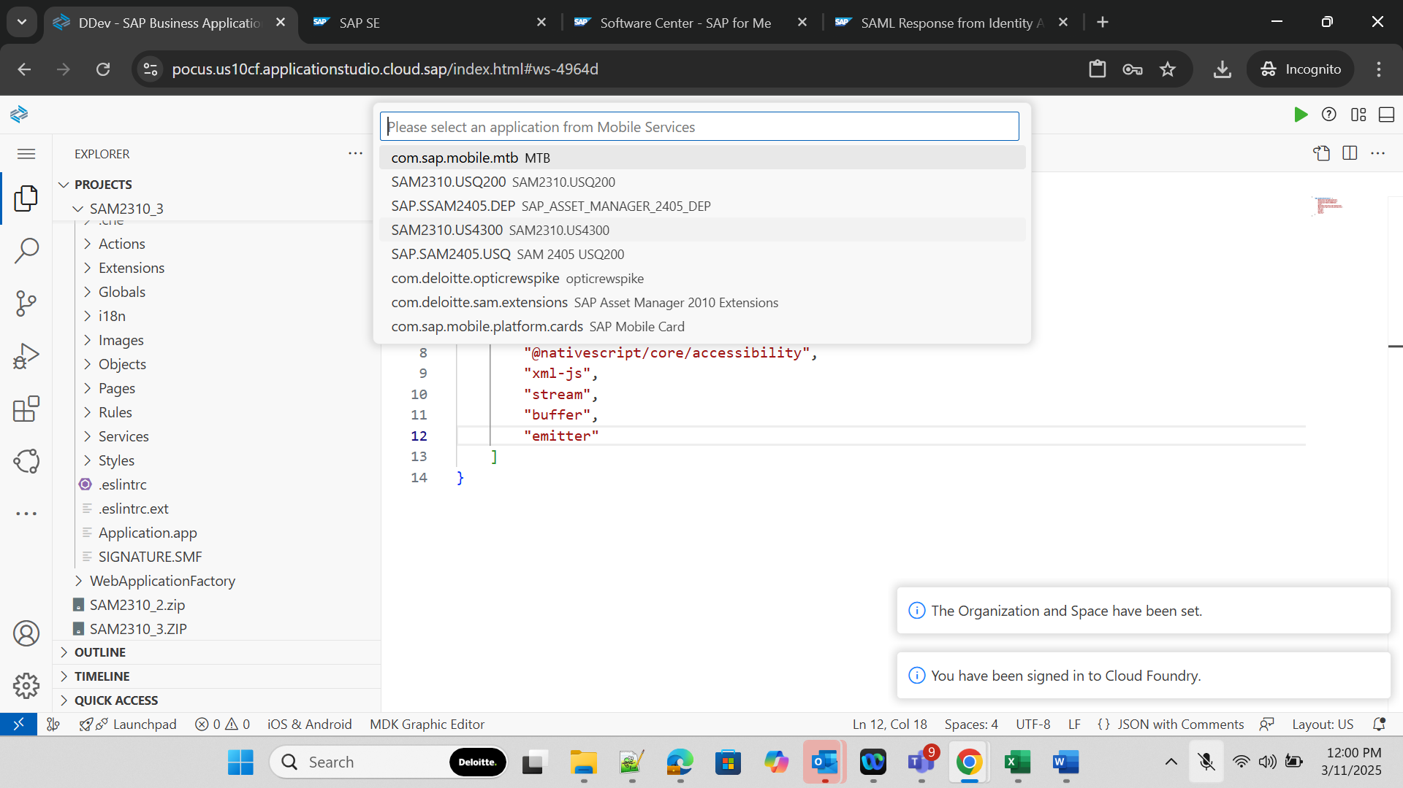

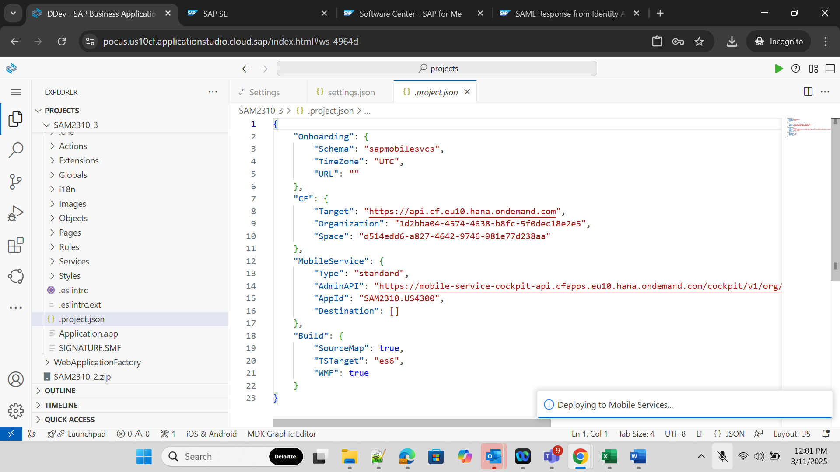

Result: Following error is coming in deployment
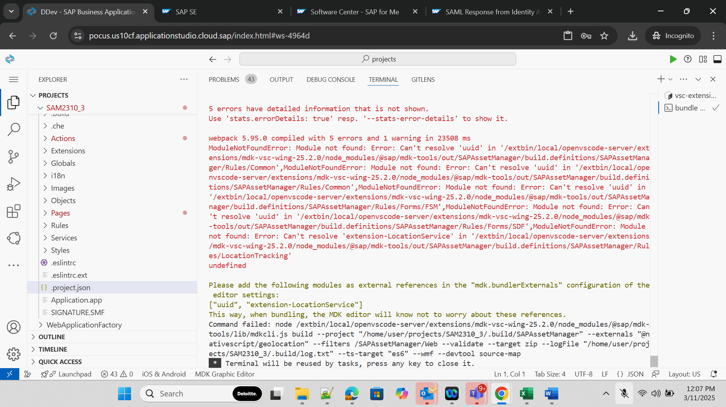

Logs:

MDK Bundler - resolving complex fragment /SAPAssetManager/Pages/Fragments/Forms/SDF/FormObjectTableSection.fragment
MDK Bundler - resolving fragment /SAPAssetManager/Pages/Fragments/Forms/SDF/FormInstanceObjectCell.fragment
MDK Bundler - resolving fragment /SAPAssetManager/Pages/Fragments/WorkOrder/ChecklistObjectCell.fragment
MDK Bundler - resolving fragment /SAPAssetManager/Pages/Fragments/Documents/DocumentsSimplePropertyCell.fragment
MDK Bundler - resolving fragment /SAPAssetManager/Pages/Fragments/CancelButton.fragment
MDK Bundler - resolving complex fragment /SAPAssetManager/Pages/Fragments/Equipment/ObjectTableSection.fragment
MDK Bundler - resolving complex fragment /SAPAssetManager/Pages/Fragments/Equipment/EquipmentObjectCell.fragment
MDK Bundler - resolving fragment /SAPAssetManager/Pages/Fragments/SyncButton.fragment
Command failed: node "/extbin/local/openvscode-server/extensions/mdk-vsc-wing-25.2.0/node_modules/@sap/mdk-tools/lib/mdkcli.js" bundle --nativescript-project "/home/user/projects/SAM2310_3/.build/SAPAssetManager/.build" --seam-project "/home/user/projects/SAM2310_3/.build/SAPAssetManager" --externals @nativescript/geolocation --filters /SAPAssetManager/Web/ /SAPAssetManager/SAPAssetManager/Web --bundle-zip-target-path "/home/user/projects/SAM2310_3/.build/SAPAssetManager/.build" --bundle-definition-path "/extbin/local/openvscode-server/extensions/mdk-vsc-wing-25.2.0/node_modules/@sap/mdk-tools/out/SAPAssetManager" --devtool "source-map" --create-bundle --ts-target "es6" --wmf
MDK Bundler - failed to create bundle
asset bundle.js 26.7 MiB [emitted] (name: bundle.js) (id hint: vendors) 1 related asset
asset dummy.js 26.7 MiB [emitted] (name: dummy.js) 1 related asset
runtime modules 22.7 KiB 12 modules
modules by path ./build.definitions/SAPAssetManager/Rules/ 6.27 MiB 5143 modules
modules by path ./build.definitions/SAPAssetManager/Actions/ 506 KiB 1149 modules
asset modules 2.64 MiB 485 modules
modules by path ./build.definitions/SAPAssetManager/Pages/ 1.61 MiB 480 modules
modules by path ./build.definitions/SAPAssetManager/Globals/ 16.6 KiB 286 modules
modules by path ./build.definitions/SAPAssetManager/i18n/*.properties 5.37 MiB 33 modules
modules by path ./build.definitions/SAPAssetManager/Extensions/ 58.5 KiB 24 modules
modules by path ./build.definitions/SAPAssetManager/Styles/ 120 KiB 8 modules
consume-shared-module modules 336 bytes 8 modules
modules by path ./build.definitions/SAPAssetManager/Services/*.service 1.14 KiB 4 modules
modules by path ../../../../css-loader/dist/runtime/*.js 2.74 KiB
../../../../css-loader/dist/runtime/sourceMaps.js 505 bytes [built] [code generated]
../../../../css-loader/dist/runtime/api.js 2.25 KiB [built] [code generated]
+ 4 modules

WARNING in ./build.definitions/SAPAssetManager/Rules/LCNC/FetchMetadata.js 10:22-39
Module not found: Error: Can't resolve 'xml-js' in '/extbin/local/openvscode-server/extensions/mdk-vsc-wing-25.2.0/node_modules/@sap/mdk-tools/out/SAPAssetManager/build.definitions/SAPAssetManager/Rules/LCNC'
@ ./build.definitions/application-index.js 4630:50-106

1 warning has detailed information that is not shown.
Use 'stats.errorDetails: true' resp. '--stats-error-details' to show it.

ERROR in ./build.definitions/SAPAssetManager/Rules/Common/guid.js 1:0-36
Module not found: Error: Can't resolve 'uuid' in '/extbin/local/openvscode-server/extensions/mdk-vsc-wing-25.2.0/node_modules/@sap/mdk-tools/out/SAPAssetManager/build.definitions/SAPAssetManager/Rules/Common'
@ ./build.definitions/application-index.js 2824:43-92

ERROR in ./build.definitions/SAPAssetManager/Rules/Common/nilGuid.js 1:0-39
Module not found: Error: Can't resolve 'uuid' in '/extbin/local/openvscode-server/extensions/mdk-vsc-wing-25.2.0/node_modules/@sap/mdk-tools/out/SAPAssetManager/build.definitions/SAPAssetManager/Rules/Common'
@ ./build.definitions/application-index.js 2863:46-98

ERROR in ./build.definitions/SAPAssetManager/Rules/Forms/FSM/FSMSmartFormsLibrary.js 11:0-36
Module not found: Error: Can't resolve 'uuid' in '/extbin/local/openvscode-server/extensions/mdk-vsc-wing-25.2.0/node_modules/@sap/mdk-tools/out/SAPAssetManager/build.definitions/SAPAssetManager/Rules/Forms/FSM'
@ ./build.definitions/application-index.js 3634:62-130

ERROR in ./build.definitions/SAPAssetManager/Rules/Forms/SDF/FormGuidCreate.js 1:0-36
Module not found: Error: Can't resolve 'uuid' in '/extbin/local/openvscode-server/extensions/mdk-vsc-wing-25.2.0/node_modules/@sap/mdk-tools/out/SAPAssetManager/build.definitions/SAPAssetManager/Rules/Forms/SDF'
@ ./build.definitions/application-index.js 3653:56-118

ERROR in ./build.definitions/SAPAssetManager/Rules/LocationTracking/LocationTrackingLibrary.js 12:0-67
Module not found: Error: Can't resolve 'extension-LocationService' in '/extbin/local/openvscode-server/extensions/mdk-vsc-wing-25.2.0/node_modules/@sap/mdk-tools/out/SAPAssetManager/build.definitions/SAPAssetManager/Rules/LocationTracking'
@ ./build.definitions/application-index.js 4636:72-150

5 errors have detailed information that is not shown.
Use 'stats.errorDetails: true' resp. '--stats-error-details' to show it.

webpack 5.95.0 compiled with 5 errors and 1 warning in 23508 ms
ModuleNotFoundError: Module not found: Error: Can't resolve 'uuid' in '/extbin/local/openvscode-server/extensions/mdk-vsc-wing-25.2.0/node_modules/@sap/mdk-tools/out/SAPAssetManager/build.definitions/SAPAssetManager/Rules/Common',ModuleNotFoundError: Module not found: Error: Can't resolve 'uuid' in '/extbin/local/openvscode-server/extensions/mdk-vsc-wing-25.2.0/node_modules/@sap/mdk-tools/out/SAPAssetManager/build.definitions/SAPAssetManager/Rules/Common',ModuleNotFoundError: Module not found: Error: Can't resolve 'uuid' in '/extbin/local/openvscode-server/extensions/mdk-vsc-wing-25.2.0/node_modules/@sap/mdk-tools/out/SAPAssetManager/build.definitions/SAPAssetManager/Rules/Forms/FSM',ModuleNotFoundError: Module not found: Error: Can't resolve 'uuid' in '/extbin/local/openvscode-server/extensions/mdk-vsc-wing-25.2.0/node_modules/@sap/mdk-tools/out/SAPAssetManager/build.definitions/SAPAssetManager/Rules/Forms/SDF',ModuleNotFoundError: Module not found: Error: Can't resolve 'extension-LocationService' in '/extbin/local/openvscode-server/extensions/mdk-vsc-wing-25.2.0/node_modules/@sap/mdk-tools/out/SAPAssetManager/build.definitions/SAPAssetManager/Rules/LocationTracking'
undefined

Please add the following modules as external references in the "mdk.bundlerExternals" configuration of the editor settings:
["uuid", "extension-LocationService"]
This way, when bundling, the MDK editor will know not to worry about these references.
Command failed: node /extbin/local/openvscode-server/extensions/mdk-vsc-wing-25.2.0/node_modules/@sap/mdk-tools/lib/mdkcli.js build --project "/home/user/projects/SAM2310_3/.build/SAPAssetManager" --externals "@nativescript/geolocation" --filters /SAPAssetManager/Web --validate --target zip --logFile "/home/user/projects/SAM2310_3/.build/log.txt" --ts-target "es6" --wmf --devtool source-map
* Terminal will be reused by tasks, press any key to close it.

